

**Project Report**

**Name: Hamza Sajid**

**Roll No: F24-599**

**Program: BSSE**

**Semester/Section: 2nd**

**Subject: OOPS**

**Session: Spring 2025**

**Submitted To: Mr Jamal Abdul Ahad**

**Department of Computer Science**

**Abbottabad University of Science & Technology**

# 📁 ****File Organizer with GUI – Project Report****

### 🧑‍💻 ****Developer:**** Hamza Sajid

### 🧰 ****Language Used:**** Python

### 🖼️ ****GUI Framework:**** Tkinter

### 📅 ****Date:**** June 2025

## 🔍 ****Project Overview****

This Python-based desktop application allows users to automatically organize files within a selected folder into categorized subfolders. It uses the **Tkinter** library to create a simple and user-friendly graphical interface and **os/shutil** libraries to handle file operations.

## 🎯 ****Objectives****

* Simplify the process of file management.
* Automatically sort files into categories (Documents, Images, Videos, Music, Archives, and Others).
* Provide a minimal and intuitive user interface.
* Support common file types and extensions.

## 🧱 ****Project Structure****

### 📂 Modules and Their Purpose:

1. **os** – Used for directory and file path manipulations.
2. **shutil** – Used to move files into categorized directories.
3. **tkinter** – Used for creating GUI elements.
4. **filedialog and messagebox** – For folder selection and optional alerts/messages.

## 📋 ****Features****

### ✅ Core Features

* **Folder Selection** via file dialog.
* **Automatic File Categorization** into:
  + 📄 Documents: .pdf, .docx, .txt, .xlsx
  + 🖼️ Images: .jpg, .jpeg, .png, .gif
  + 🎥 Videos: .mp4, .mkv, .avi
  + 🎵 Music: .mp3, .wav
  + 📦 Archives: .zip, .rar, .7z
  + 📁 Others: All uncategorized files
* **Dynamic Folder Creation**: Creates subfolders as needed.
* **Status Update**: Live update of process status on GUI.

## 🖼️ ****User Interface****

### GUI Elements:

* **Label**: Instructional text for the user.
* **Button**: Triggers folder selection dialog.
* **Status Label**: Displays real-time feedback such as “Organizing...” and “Files organized successfully.”

### Layout:

* Window Size: 400x200 px
* Elements stacked vertically using .pack() method for simplicity and clarity.

## 🔄 ****Workflow Diagram****

pgsql

CopyEdit

[User Clicks Browse Folder]

↓

[Select Directory Dialog Opens]

↓

[Path Returned to Function]

↓

[Loop Through Each File]

↓

[Match Extension to Category]

↓ ↓

[Yes] → Move File to Folder

[No] → Move to 'Others' Folder

↓

[Update Status Label with Result]

## ✅ ****Strengths****

* Easy to use, no technical skill required.
* Clean and minimal interface.
* Well-structured and easy-to-maintain code.
* Supports a variety of commonly used file types.
* Prevents clutter by organizing into folders.

## 🧪 ****Possible Enhancements****

1. **Extension Customization** – Let users add/remove custom extensions.
2. **Preview Mode** – Show users how files will be organized before moving.
3. **Undo Option** – Allow undoing the last organization session.
4. **Drag-and-Drop Interface** – Make folder selection even easier.
5. **Recursive Option** – Include files from subdirectories as well.

## 🔒 ****Security Considerations****

* Ensures only files (not folders) are moved.
* Avoids deletion; only uses shutil.move to prevent data loss.

## 🧪 ****Test Results****

| **Test Case** | **Input Type** | **Expected Outcome** | **Result** |
| --- | --- | --- | --- |
| Folder with mixed files | .jpg, .mp3 | Sorted into proper folders | ✅ Success |
| Folder with unknown extensions | .xyz | Moved to 'Others' folder | ✅ Success |
| Empty folder | No files | Status updated, no error | ✅ Success |
| User cancels dialog | No path selected | Message: No folder selected | ✅ Success |

. Screen Shorts:

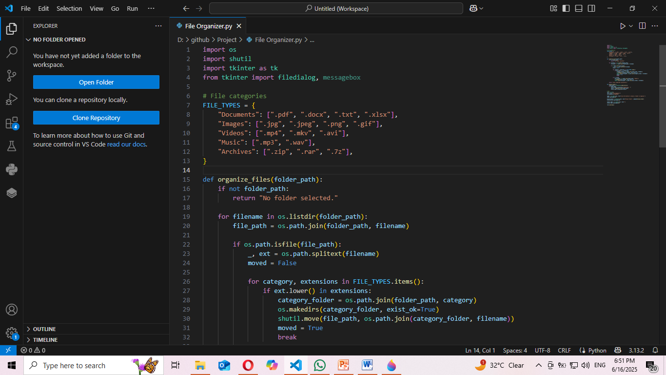

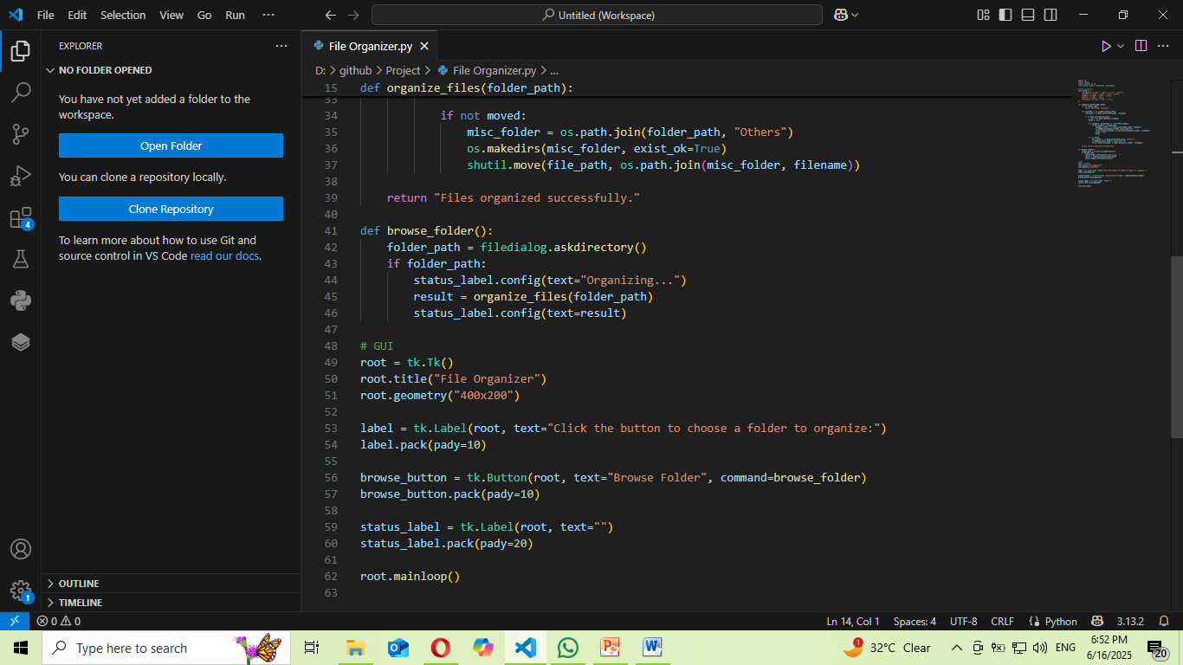

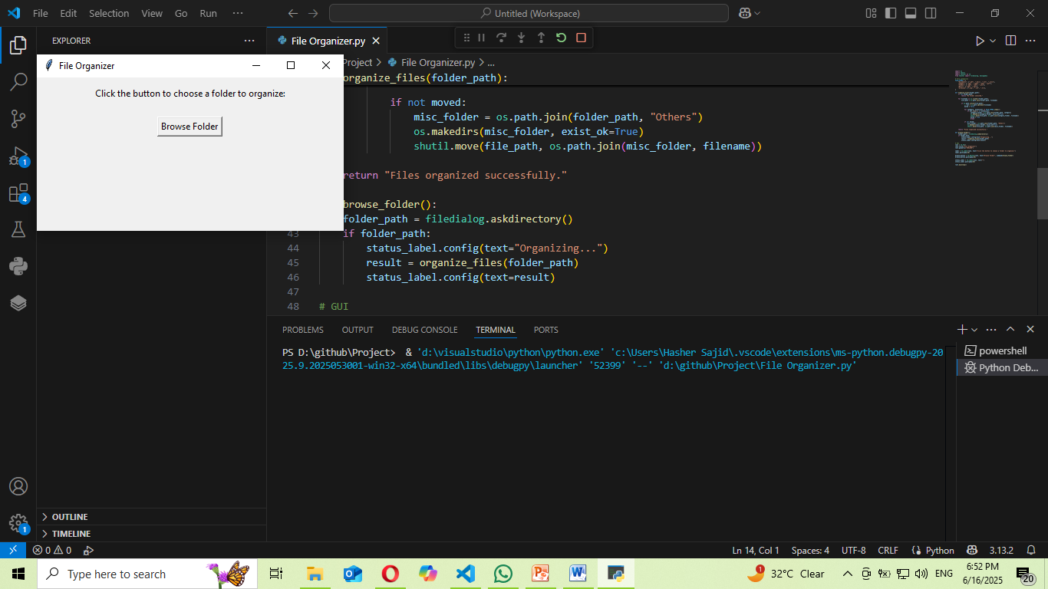

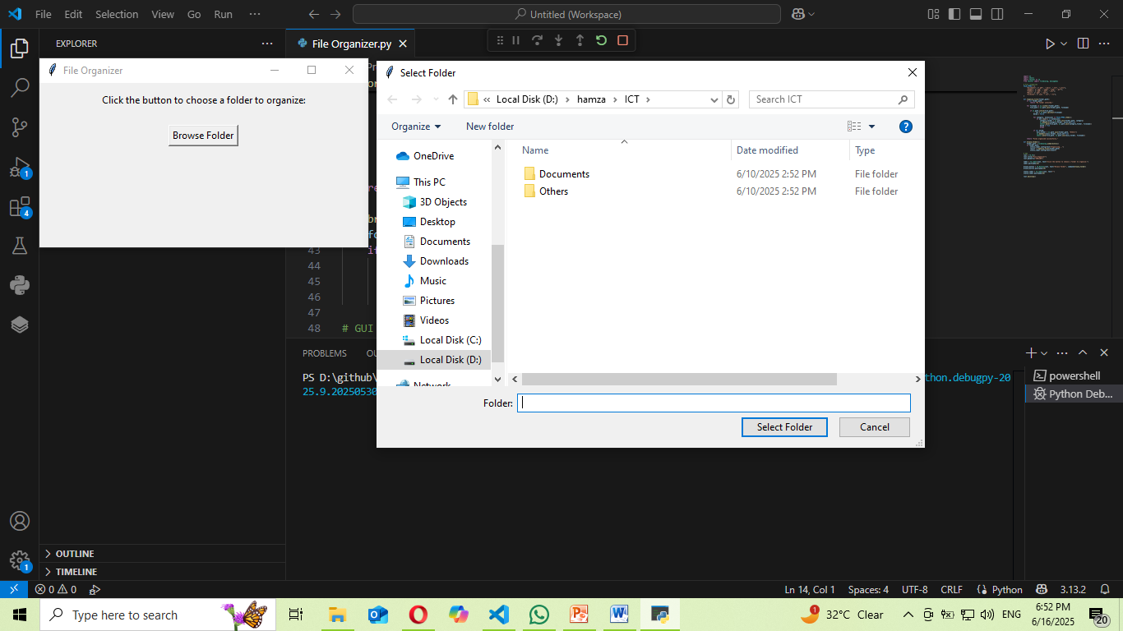

## 📦 ****Conclusion****

This **File Organizer** project demonstrates practical Python programming and GUI design with real-world utility. It provides a clean solution for managing digital clutter and introduces key programming concepts like file I/O, user interface design, and modular coding. It's an excellent tool for students and professionals alike to enhance productivity.

**:GIT HUB LINK:**

[**https://github.com/hamza-101-star/Project.git**](https://github.com/hamza-101-star/Project.git)